NATIONAL UNIVERSITY OF MODERN LANGUAGE ISLAMABAD
Lab_02


Submitted to:
Ms. Fatima Gillani
Submitted by:
Zulqarnain Hassan
Roll No: …………………… SP21379
Subject: …………………… SCD
Department: ……………… BSSE-4-Afternoon
Date: ……………………… 23-09-2024

Task 01
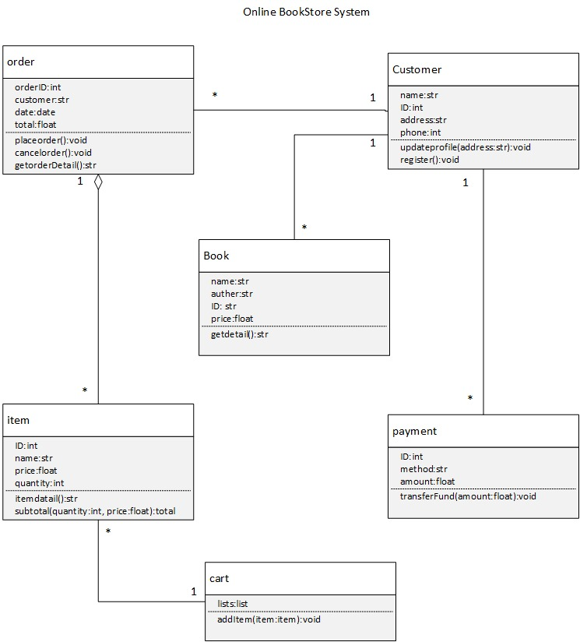

Task 02
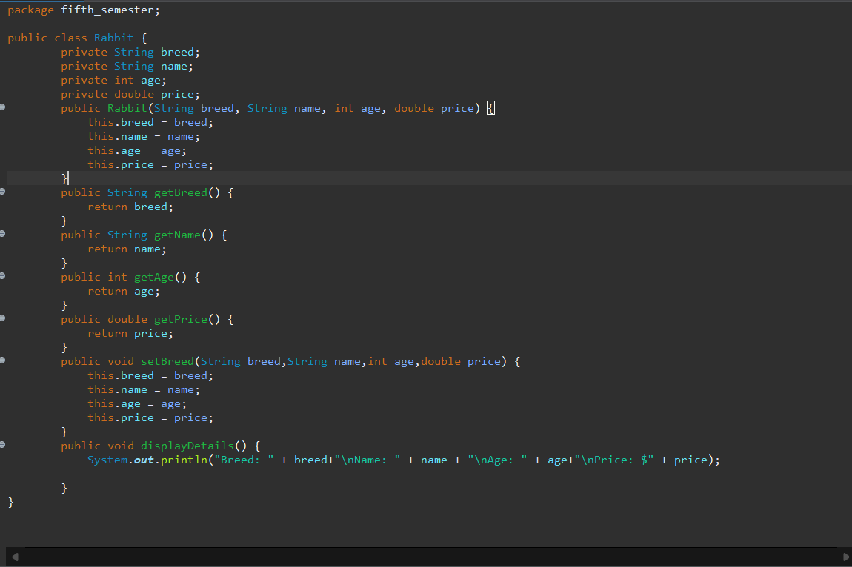

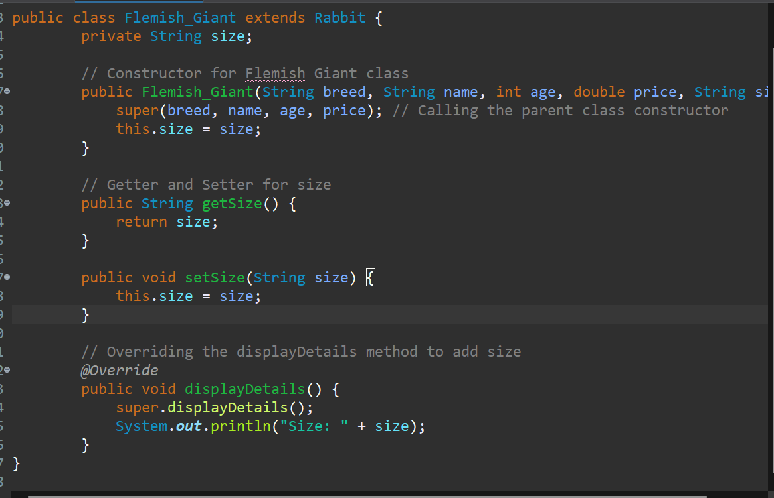
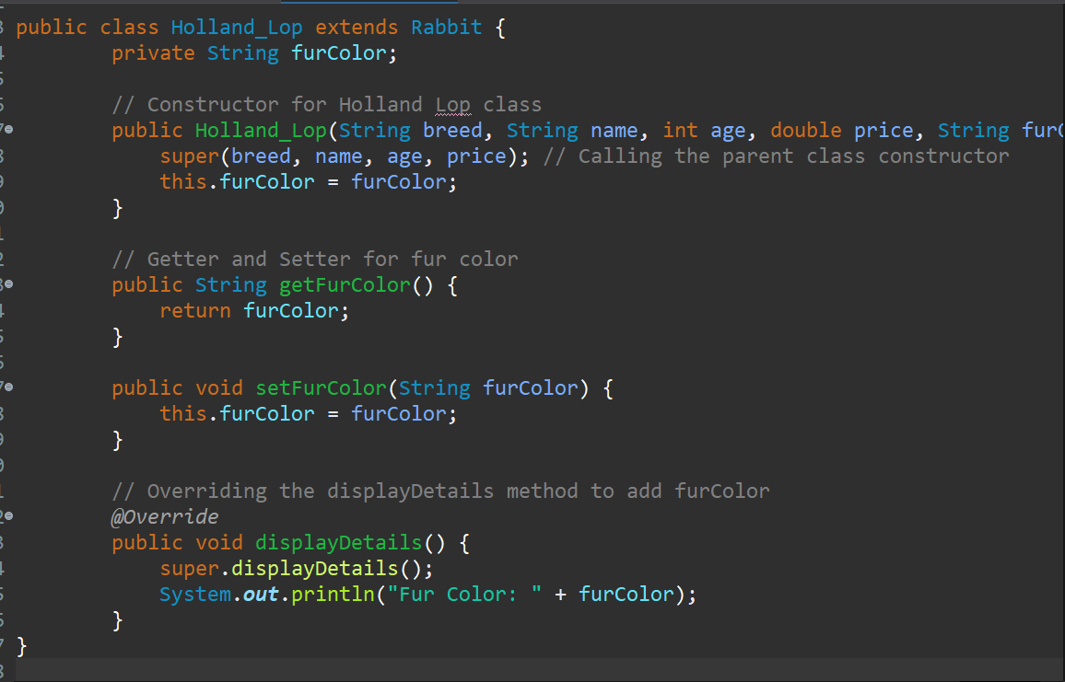

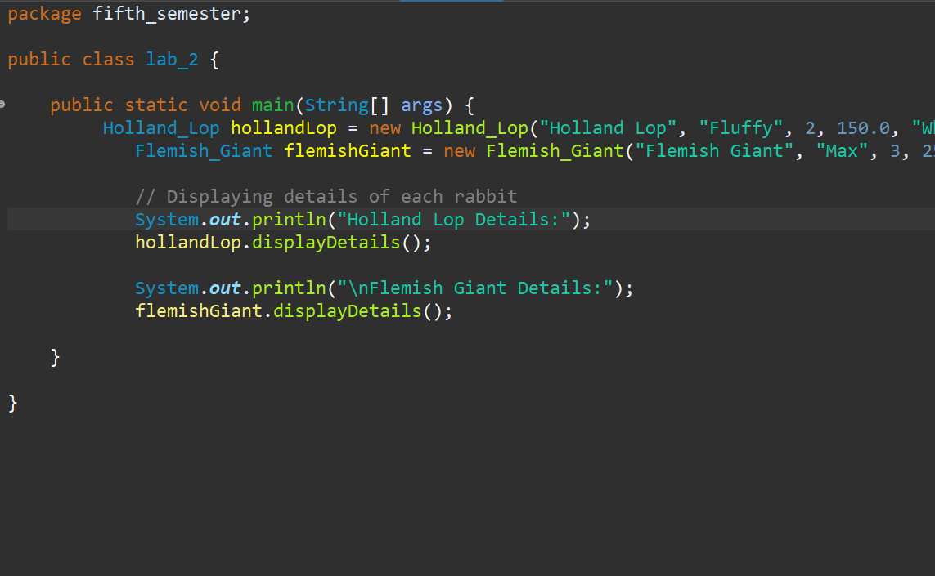

Output:
